Dynatrace AppMon Quality & Performance Monthly Report
July 2018



Publication Detail

Document version
Version | Date | Author | Remarks
1.0 | August 01, 2018 | Miftah Reza Maulana | Intial Document

Document authorization
PT. Mitra Integrasi Informatika |  | PT. Manulife Indonesia |  | PT. Manulife Indonesia
Rahmat Julizar |  | Wayan Budiastika |  | Adi Wijaya Sutanto
Date: |  | Date: |  | Date:

Table of Contents
Publication Detail 1
Document version 1
Document authorization 1
1. Introduction 4
2. Manulife Production Server Ovierview 4
2.1 mliprd78 4
2.1.1 CPU Usage 4
2.1.2 Memory 5
2.1.3 Network Utilization 5
2.1.4 Disk 6
2.1.5 Process 7
2.1.6 Incidents/Issue 8
2.2 mliprd80 9
2.2.1 CPU Usage 9
2.2.2 Memory 9
2.2.3 Network Utilization 10
2.2.4 Disk 10
2.2.5 Process 11
2.2.6 Incidents/Issue 11
2.3 mliprd81 12
2.3.1 CPU Usage 12
2.3.2 Memory 12
2.3.3 Network Utilization 13
2.3.4 Disk 13
2.3.5 Process 14
2.3.6 Incidents/Issue 15
2.4 mliprd82 16
2.4.1 CPU Usage 16
2.4.2 Memory 16
2.4.3 Network Utilization 17
2.4.4 Disk 17
2.4.5 Process 18
2.4.6 Incidents/Issue 19
3. Report Summary 20

Introduction
This document use as the reference for Quality & Performance Monthly Report Period July 2018 (PT. Manulife Indonesia) using Dynatrace AppMon.

Manulife Production Server Ovierview

mliprd78
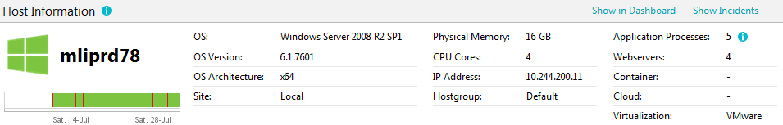

CPU Usage
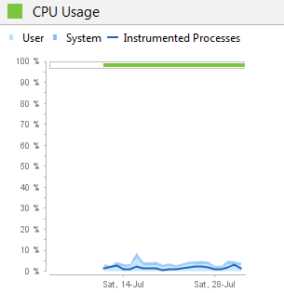

Memory
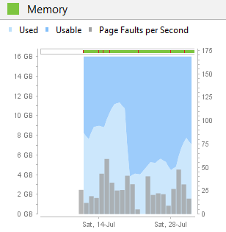

Network Utilization
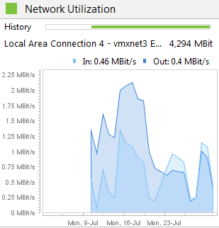

Disk
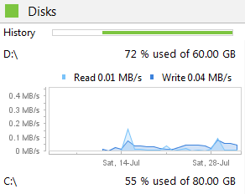
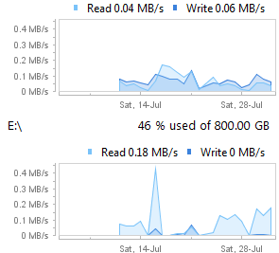

Process
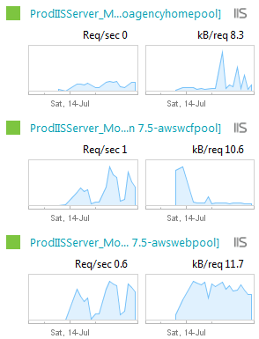
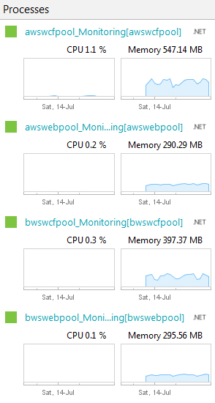

Incidents/Issue
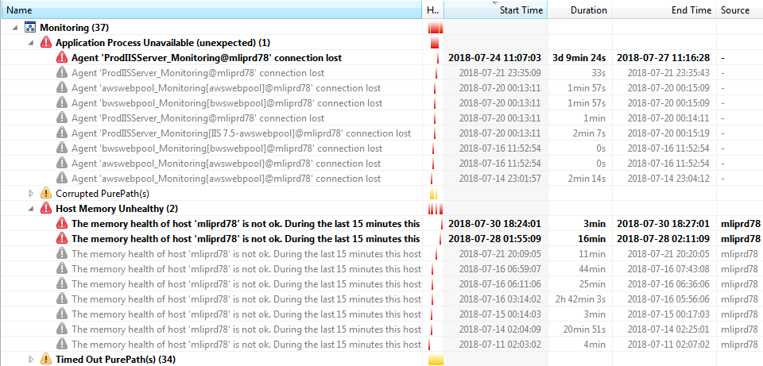

mliprd80
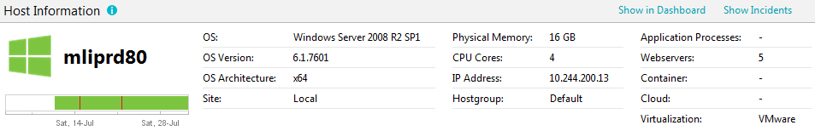

CPU Usage
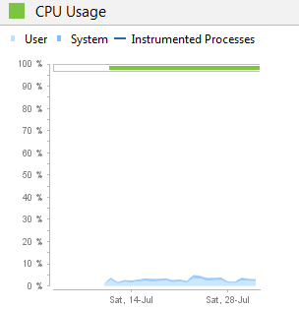

Memory
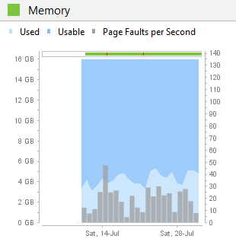

Network Utilization
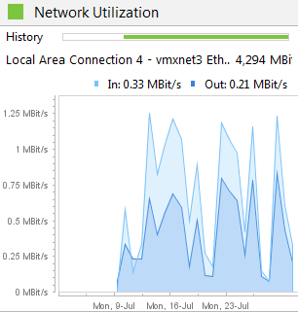

Disk
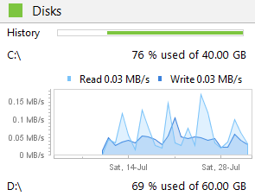
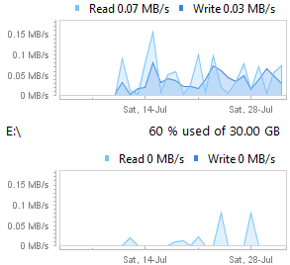

Process
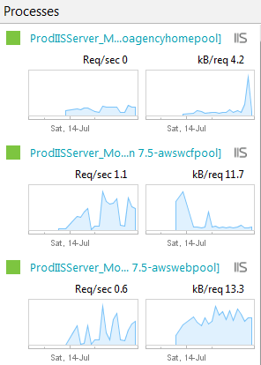

Incidents/Issue
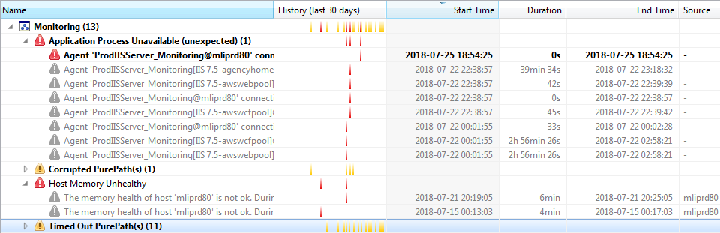

mliprd81
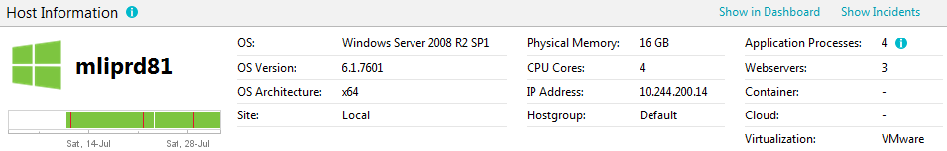

CPU Usage
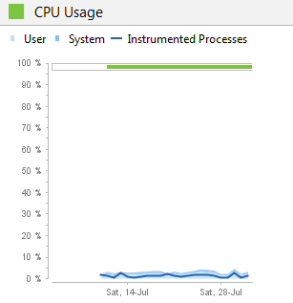

Memory
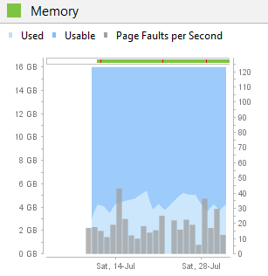

Network Utilization
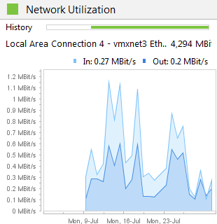

Disk
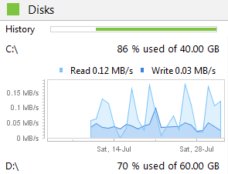
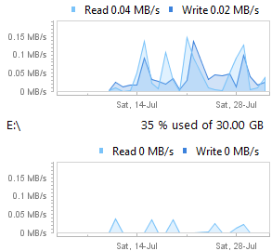

Process
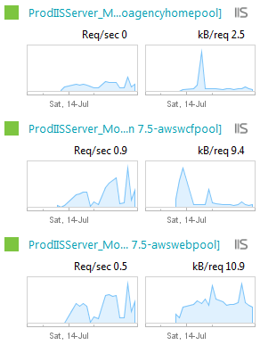
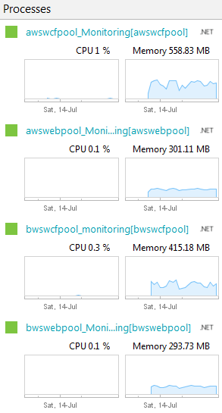

Incidents/Issue
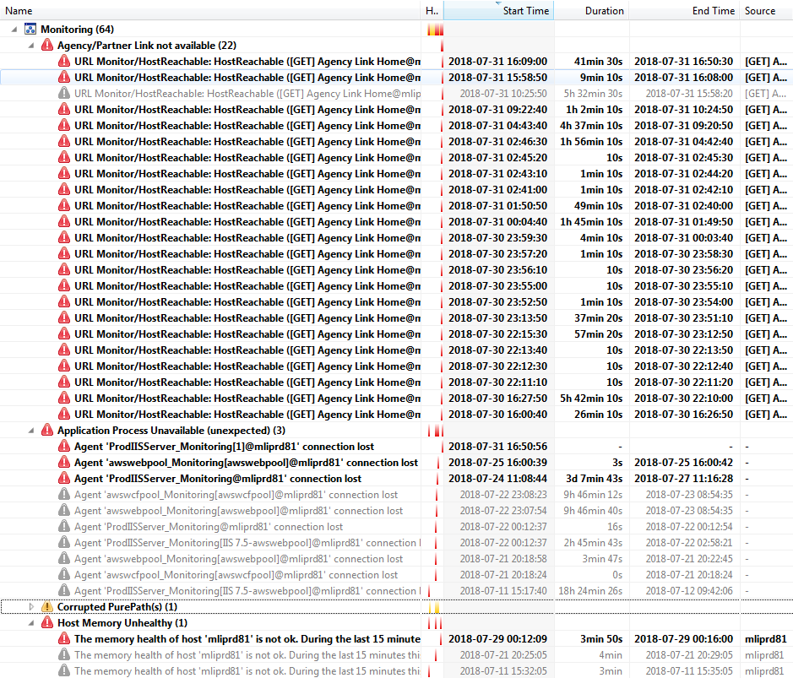

mliprd82
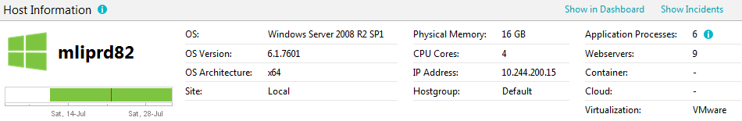

CPU Usage
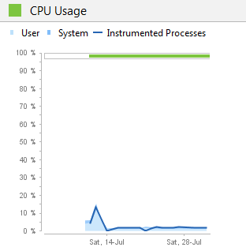

Memory
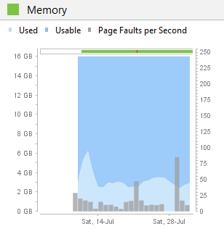

Network Utilization
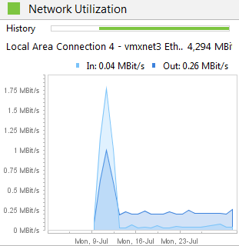

Disk
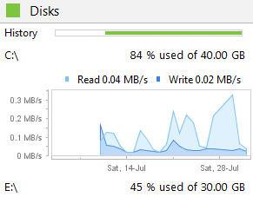
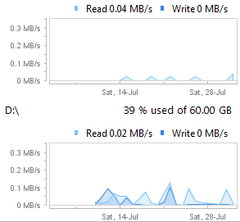

Process
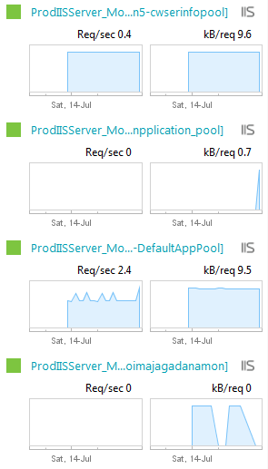
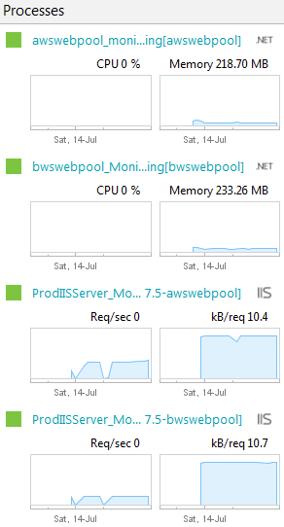

Incidents/Issue
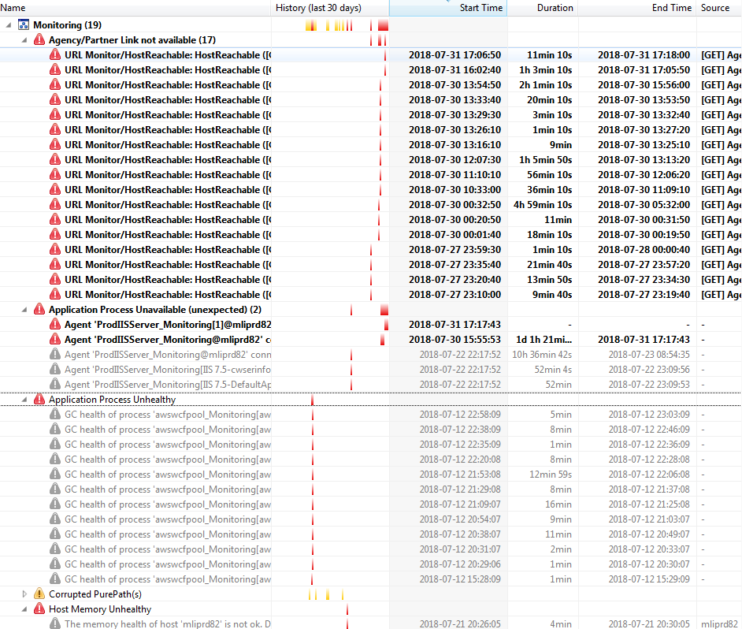

Report Summary
The table below is the summary report based on Manulife Production Server Overview :
mliprd78
Resource | Status | Information
- CPU Usage | ✔ | Based on CPU Usage of mliprd78, overall CPU Usage for over 30 days is normal. Because it is not more than 10% from total 100%.  The CPU should be have no problem
- Memory | ✔ | Based on Memory of mliprd78, overall Memory Usage for over 30 days is normal. Because it is not more than 12GB from total 16GB. The Page Fault per second sometimes increase but still tolerable.  The Memory should be have no problem
- Network Utilization | ✔ | Based on Network Utilization of mliprd78, overall Network Utilization for over 30 days is normal. As long as there is a traffic which means server still give a response.  The Network should be have no problem
- Disk | ✔ | Based on Disk of mliprd78, overall Disk for over 30 days is normal. Because the Read & Write speed is quite low. Free disk space for all harddrive still tolerable.  The Network should be have no problem
- Process | ✔ | Based on Process of mliprd78, overall Process for over 30 days is normal. Because the traffic & resource usage still tolerable  The Process should be have no problem
- Incidents/Issue | ✔ | Based on Incidents/Issue of mliprd78, overall Incidents/Issue that happen for over 30 days is normal. Sometimes memory usage of mliprd78 increase and detected as issue but it back to normal. No severity issue so far.  The Incidents/Issue should be have no problem
mliprd80
Resource | Status | Information
- CPU Usage | ✔ | Based on CPU Usage of mliprd80, overall CPU Usage for over 30 days is normal. Because it is not more than 10% from total 100%.  The CPU should be have no problem
- Memory | ✔ | Based on Memory of mliprd80, overall Memory Usage for over 30 days is normal. Because it is not more than 12GB from total 16GB. The Page Fault per second sometimes increase but still tolerable.  The Memory should be have no problem
- Network Utilization | ✔ | Based on Network Utilization of mliprd80, overall Network Utilization for over 30 days is normal. As long as there is a traffic which means server still give a response.  The Network should be have no problem
- Disk | ✔ | Based on Disk of mliprd80, overall Disk for over 30 days is normal. Because the Read & Write speed is quite low. Free disk space for all harddrive still tolerable.  The Network should be have no problem
- Process | ✔ | Based on Process of mliprd80, overall Process for over 30 days is normal. Because the traffic & resource usage still tolerable  The Process should be have no problem
- Incidents/Issue | ✔ | Based on Incidents/Issue of mliprd80, overall Incidents/Issue that happen for over 30 days is normal. Sometimes memory usage of mliprd80 increase and detected as issue but it back to normal. No severity issue so far.  The Incidents/Issue should be have no problem
mliprd81
Resource | Status | Information
- CPU Usage | ✔ | Based on CPU Usage of mliprd81, overall CPU Usage for over 30 days is normal. Because it is not more than 10% from total 100%.  The CPU should be have no problem
- Memory | ✔ | Based on Memory of mliprd81, overall Memory Usage for over 30 days is normal. Because it is not more than 12GB from total 16GB. The Page Fault per second sometimes increase but still tolerable.  The Memory should be have no problem
- Network Utilization | ✔ | Based on Network Utilization of mliprd81, overall Network Utilization for over 30 days is normal. As long as there is a traffic which means server still give a response.  The Network should be have no problem
- Disk | ✔ | Based on Disk of mliprd81, overall Disk for over 30 days is normal. Because the Read & Write speed is quite low. Free disk space for all harddrive still tolerable.  The Network should be have no problem
- Process | ✔ | Based on Process of mliprd81, overall Process for over 30 days is normal. Because the traffic & resource usage still tolerable  The Process should be have no problem
- Incidents/Issue | ✘ | Based on Incidents/Issue of mliprd81, overall Incidents/Issue that happen for over 30 days is not normal. Sometimes Agency Link or Partner Link in mliprd81 can’t be accessed.  Problem Detected. The Administrator should take an action to solve the issue
mliprd82
Resource | Status | Information
- CPU Usage | ✔ | Based on CPU Usage of mliprd82, overall CPU Usage for over 30 days is normal. Because it is not more than 10% from total 100%.  The CPU should be have no problem
- Memory | ✔ | Based on Memory of mliprd82, overall Memory Usage for over 30 days is normal. Because it is not more than 12GB from total 16GB. The Page Fault per second sometimes increase but still tolerable.  The Memory should be have no problem
- Network Utilization | ✔ | Based on Network Utilization of mliprd82, overall Network Utilization for over 30 days is normal. As long as there is a traffic which means server still give a response.  The Network should be have no problem
- Disk | ✔ | Based on Disk of mliprd82, overall Disk for over 30 days is normal. Because the Read & Write speed is quite low. Free disk space for all harddrive still tolerable.  The Network should be have no problem
- Process | ✔ | Based on Process of mliprd82, overall Process for over 30 days is normal. Because the traffic & resource usage still tolerable  The Process should be have no problem
- Incidents/Issue | ✘ | Based on Incidents/Issue of mliprd82, overall Incidents/Issue that happen for over 30 days is not normal. Sometimes Agency Link or Partner Link in mliprd81 can’t be accessed.  Problem Detected. The Administrator should take an action to solve the issue

